A HAND TO THE FARMER

1. **Introduction**

Agriculture is an important sector which plays a crucial role in the development of a country’s economy. Not only being the livelihood, it is also the bread and butter for many farmers. So in-turn farmers are the backbone of the country. India being an agrarian country it’s our responsibility to flourish our farmers.

1. **Problem statement**

“When we buy agricultural goods,the end credit goes to the farmer but in reality the mediators are the people who make most of the profit leaving the farmer with very less capital .An app must be developed to establish a link between the farmer and the government to ease the process of trading goods directly. Due to lack of education the yield has a low output . Hence a system has to be developed to improve the yield.”

1. **Project layout**

Farmers are an important asset to the country and it's their responsibility to ensure their well-being. The mediator buys the good at a very low rate from the farmers and sell it at an higher price in the market taking up huge profits.

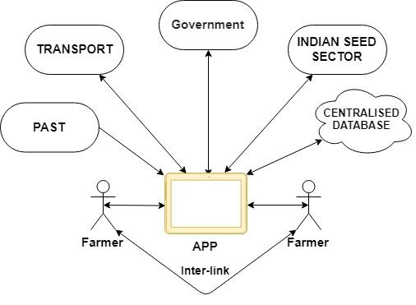

The proposed system has been designed to provide the farmer live-time guidance with the help of Green-link powered by the P∆ST.

P∆ST is a user-friendly device designed to assist the farmers in determining the fertility of soil live-time. Green-link simple yet efficient app designed to improve the connectivity of farmers. The smart and compact device is capable of predicting the type of crop that can be cultivated in the plot on the basis of the fertility of the soil.

1. **Conclusion**

The proposed project is designed and developed keeping in mind the major issues faced by the farmers. It assures real-time guidance in all vernacular languages making the design user convenient . Being highly durable and efficient it is meant for the fields. The system is automated hence the user requires less time to adjust to the amazing features of the app. Our future plans are to automate the whole farming procedures making our countrymen smart and effective in their work.

1. **Acknowledgement**

We express our sincere gratitude to Prof.Rajesh I S and Prof.Nikil for encouragement and guidance.